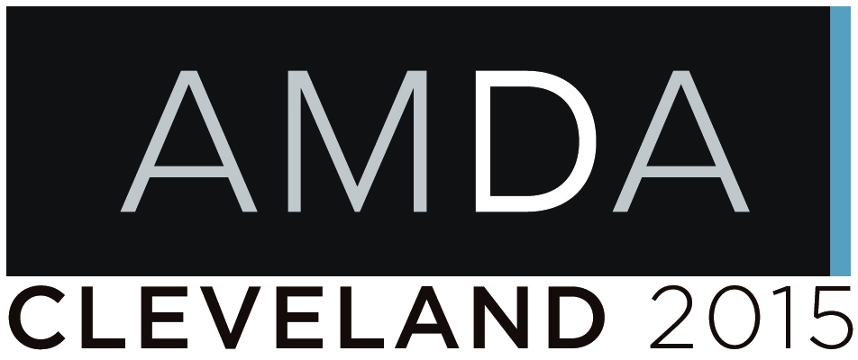

Art Museum Development Association
2015 Conference Registration & Membership Enrollment Form

Thank you for your interest in the Art Museum Development Association. Please complete this form to become a member of this elite professional organization or register for the 2014 conference.

Enrollment/Registration options
□ $850.00 – Annual membership and conference registration
□ $750.00 – Conference registration only (please note that AMDA membership is required to attend)
□ $100.00 – Annual membership only

Member/Attendee information

_____________________________________________________________________________________
Name

_____________________________________________________________________________________
Organization

_____________________________________________________________________________________
Position/Title

_____________________________________________________________________________________
Address

_____________________________________________________________________________________
City State ZIP

_____________________________________________________________________________________
Phone Email

Payment method
□ A check for $__________ made payable to The Cleveland Museum of Art is enclosed.
□ Please charge $__________ to the credit card listed below.
□ American Express □ Discover □ MasterCard □ Visa

______________________________________________________________________________
Credit Card Number

______________________________________________________________________________
Expiration Date Security Code Name on Card

______________________________________________________________________________
Signature

Please complete this form in its entirety and forward it with your payment to:

The Cleveland Museum of Art
Attn: Roberto A. Prcela
11150 East Boulevard
Cleveland, OH 44106-1797
Phone: 216.707.2151
Fax: 216.707.6551
Email: rap@clevelandart.org

Membership payments are final. Conference fee refunds will not be issued after April 15, 2015.

